Lab-2

1. Using Frames divide the web page like following:

Code:

# 1.html

<html lang="en">

<head>

<meta charset="UTF-8">

<title>1</title>

</head>

<frameset rows="20%,60%,20%">

<frame name="head" src="11.html">

<frameset cols="20%,80%">

<frame name="links" src="12.html">

<frame name="info" src="13.html">

</frameset>

<frame name="foot" src="14.html">

</frameset>

</html>

# 11.html

<html>

<body>

This is heading

</body>

</html>

# 12.html

<html>

<body>

Links here

<br>

<br>

<a href="" style="color: black;">Home</a><br>

<a href="" style="color: black;">About</a><br>

<a href="" style="color: black;">Contact us</a><br>

</body>

</html>

# 13.html

<html>

<body>

Here is information

</body>

</html>

# 14.html

<html>

<body>

This is footer

</body>

</html>

Answer:

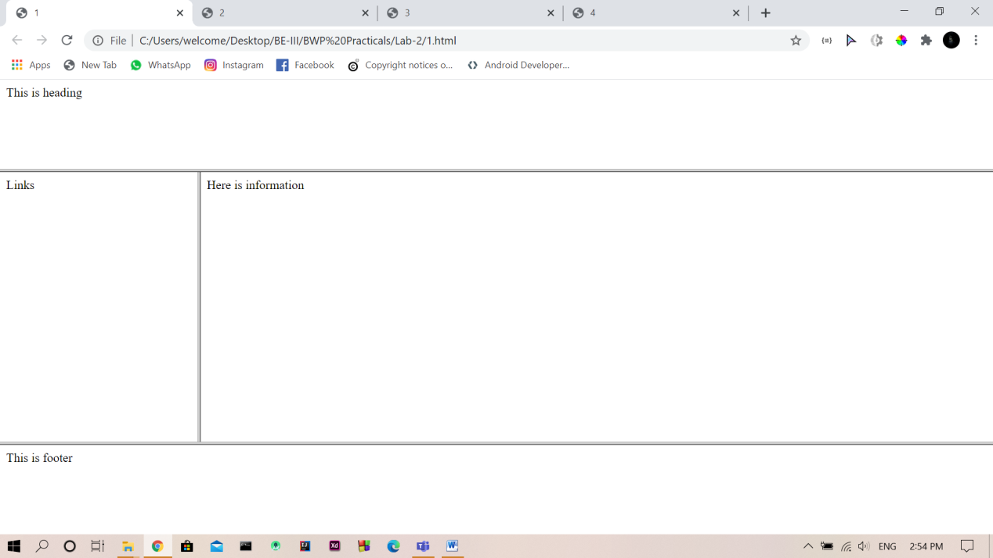

1. Design a simple static website using HTML Frameset, Frame Having Following Structure

Code:

# 2.html

<html lang="en">

<head>

<meta charset="UTF-8">

<title>2</title>

</head>

<frameset rows="20%,80%">

<frame name="header" src="21.html">

<frameset cols="20%,80%">

<frame name="links" src="22.html">

<frame name="detail" src="23.html">

</frameset>

</frameset>

</html>

# 21.html

<!DOCTYPE html>

<html lang="en">

<head>

<meta charset="UTF-8">

<title></title>

</head>

<body style="background-color: blue;color: white; position: absolute;top: 50%;left: 50%;transform: translate(-50%,-50%);">

This is header

</body>

</html>

# 22.html

<!DOCTYPE html>

<html lang="en">

<head>

<meta charset="UTF-8">

<title></title>

</head>

<body style=" position: absolute; background-color: blue;color: white;top: 50%;left: 50%;transform: translate(-50%,-50%);">

<a href="23.html" style="color: white;" target="detail">Home</a><br>

<a href="24.html" style="color: white;" target="detail">About</a><br>

<a href="25.html" style="color: white;" target="detail">Contact us</a><br>

</body>

</html>

# 23.html

<html>

<body style="position: absolute;top: 50%;left: 50%;transform: translate(-50%,-50%);">

THis is home.html

</body>

</html>

# 24.html

<html>

<body style="position: absolute;top: 50%;left: 50%;transform: translate(-50%,-50%);">

THis is About.html

</body>

</html>

# 25.html

<html>

<body style="position: absolute;top: 50%;left: 50%;transform: translate(-50%,-50%);">

THis is Contact us.html

</body>

</html>

Answer:

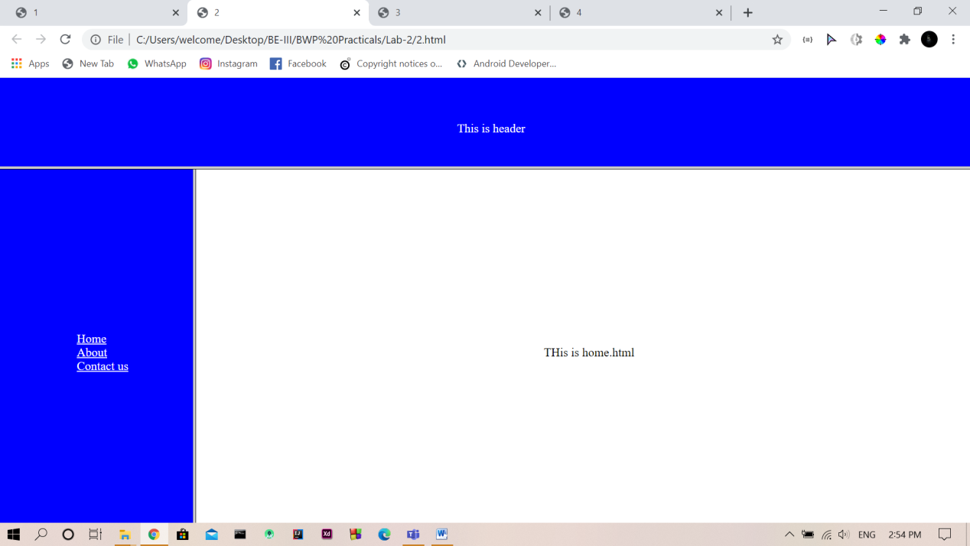

1. Create a student registration form using the following tags <form>, <input> , <textarea>, <button>, <select>, <option>The registration form must consist of following information : First Name, Middle Name, Last Name, Gender (use radio button), Address, Phone No., email id, Hobbies (use checkbox), City, State, Country, College Name (use dropdown menu)

Code:

<!DOCTYPE html>

<html lang="en">

<head>

<meta charset="UTF-8">

<title>3</title>

</head>

<body>

<form action="" style="text-align: center;">

<label for="fn">First Name : </label>

<input type="text" name="fn">

<br><br>

<label for="mn">middle Name : </label>

<input type="text" name="mn">

<br><br>

<label for="ln">Last Name : </label>

<input type="text" name="ln">

<br><br>

<label for="g">Gender : </label>

<input type="radio" name="g">Male

<input type="radio" name="g">Female

<br><br>

<label for="add">Address : </label>

<textarea name="" id="" cols="30" rows="5"></textarea>

<br><br>

<label for="">Phone no. : </label>

<input type="number">

<br><br>

<label for="">Email : </label>

<input type="email">

<br><br>

<label for="">Hobbies : </label>

<input type="checkbox"> Playing Games

<input type="checkbox"> Reading

<input type="checkbox"> Dancing

<br><br>

<label for="">City : </label>

<input type="text">

<br><br>

<label for="">State : </label>

<input type="text">

<br><br>

<label for="">Country : </label>

<input type="text">

<br><br>

<label for="">College : </label>

<select name="" id="">

<option value="">

MSU

</option>

<option value="">IIT</option>

<option value="">NIRMA</option>

<option value="">SPU</option>

<option value="">etc....</option>

</select>

<br><br>

<button type="reset">Reset</button>

<button type="submit">Submit</button>

</form>

</body>

</html>

Answer:

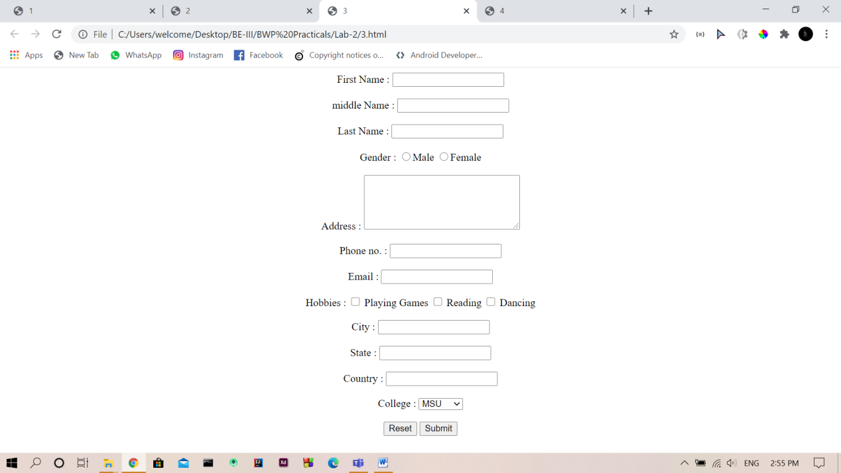

1. Design MSU Home page using HTML5 and also include collage video in it.

Code:

<!DOCTYPE html>

<html lang="en">

<head>

<meta charset="UTF-8">

<title>4</title>

</head>

<body style="margin: 0;padding: 0;">

<header style="height: 100vh ;color: white;position: relative; background-color: black;">

<img src="ms.jpg" alt="" style="opacity: 0.5;height: 100vh; padding:0;width: 100%;">

<table style="position: absolute; top: 0; ;padding-left: 30px; ">

<tr>

<td> <img src="image1.png" width="90px" alt="MSU" style="background-color: white;padding: 10px;"></td>

<td style="text-align: left;"><h2>The Maharaja Sayajirao University of Baroda

</h2></td>

</tr>

<tr align="center ">

<td style="text-align: center;" colspan="2">

<ul style="">

<li style="list-style: none;float: left; margin: 10px; font-size: 20px;">Home &#709;</li>

<li style="list-style: none;float: left; margin: 10px; font-size: 20px">About MSU &#709;</li>

<li style="list-style: none;float: left; margin: 10px; font-size: 20px">Administration &#709;</li>

<li style="list-style: none;float: left; margin: 10px; font-size: 20px">Acadamics &#709;</li>

<li style="list-style: none;float: left; margin: 10px; font-size: 20px">Central facility &#709;</li>

<li style="list-style: none;float: left; margin: 10px; font-size: 20px">Students &#709;</li>

<li style="list-style: none;float: left; margin: 10px; font-size: 20px">Imp Links &#709;</li>

<li style="list-style: none;float: left; margin: 10px; font-size: 20px">Recruitment &#709;</li>

<li style="list-style: none;float: left; margin: 10px; font-size: 20px">COVID-19 &#709;</li>

<li style="list-style: none;float: left; margin: 10px; font-size: 20px">Contacts &#709;</li>

</ul>

</td>

</tr>

<tr>

<td><span style="font-size: 30px;"><br>Quality Higher Education</span></td>

</tr>

<tr>

<td ><span style="font-size: 50px">Accredited with 'A' <br>

Grade by NAAC</span></td>

<td><span style="font-size: 30px;">Admission 2020-2021 <br>MSUB Circular Examiniation Dates Augest 2020-2021</span></td>

</tr>

<tr>

<td colspan="2">

<h2>Any successful career starts with good education. Together with us you will have deeper knowledge of the subjects that will be especially useful for you when climbing the career ladder.</h2>

</td>

</tr>

<tr>

<td>

<button style="background-color: #0D2D62; color: white;font-size: 20px; border-radius: 20px;padding: 20px;">MSUB Circular Examination Dates Augest 2020-2021</button>

</td>

</tr>

</table>

</header>

<section style="height: 100vh;margin-top: 30px;">

<div>

<table width="100%" cellpadding="30px">

<tr>

<td width="50%">

<video autoplay controls>

<source src="VID-20200430-WA0000.mp4" type="video/mp4">

<source src="VID-20200430-WA0000.ogg" type="video/ogg">

</video>

</td>

<td>

<h1 style="font-size: 40px;">Welcome to <br><span style="color: red;">

The Maharaja Sayajirao University of Baroda</span></h1>

<br><br>

<p style="font-size: 20px;">India's internationally renowned The Maharaja Sayajirao University of Baroda (1949) has blossomed from the Baroda College (1881) which is one of the oldest centres of learning in western India. MSU is the only state University with a residential, unitary character having English as sole medium of instruction with more than 1200 well-qualified faculty members and 1500 administrative staff to facilitate the learning of more than 35000 students having cosmopolitan life on campus.</p>

<br>

<button style="border: 2px solid #0D2D62; background-color: white; box-shadow: 1px; border-radius: 30px;font-size: 20px;padding: 20px">Learn More</button>

</td>

</tr>

</table>

</div>

</section>

<section style="background-color: #0D2D62; padding: 20px; margin-top: 30px;">

<div>

<div style="text-align: center; margin-top: 70px;">

<span style=" color: white ; font-size: 60px;">Acadamics</span>

<br><br><br><br><br><br>

<span style="color: white; font-size: 20px;">Our Featured Programs are selected through a rigorous process and <br>

uniquely created every semester for our students.</span>

<br><br><br><br>

</div>

<br><br><br>

<table width="100%" cellspacing="20px" align="center">

<tr>

<td height="300px" width="25%" style="background-color: white;">

<img src="arts.jpg" alt="" width="280" style="">

<br><br>

<span style="color: red ;margin: 10px;font-size: 25px">FACULTY OF ARTS</span>

</td>

<td height="300px" width="25%" style="background-color: white;">

<img src="science.jpg" alt="" width="280" style="">

<br><br>

<span style="color: red ;margin: 10px;font-size: 25px"> FACULTY OF SCIENCE</span>

</td>

<td height="300px" width="25%" style="background-color: white;">

<img src="psychology.jpg" alt="" width="280" style="">

<br><br>

<span style="color: red ;margin: 10px;font-size: 25px">FACULTY OF EDUCATION AND PSYCHOLOGY</span>

</td>

<td height="300px" width="25%" style="background-color: white;">

<img src="commerce.jpg" alt="" width="280" style="">

<br><br>

<span style="color: red ;margin: 10px;font-size: 25px">FACULTY OF COMMERCE</span>

</td>

</tr>

<tr>

<td height="300px" width="25%" style="background-color: white;">

<img src="arts.jpg" alt="" width="280" style="">

<br><br>

<span style="color: red ;margin: 10px;font-size: 25px">FACULTY OF ARTS</span>

</td>

<td height="300px" width="25%" style="background-color: white;">

<img src="science.jpg" alt="" width="280" style="">

<br><br>

<span style="color: red ;margin: 10px;font-size: 25px"> FACULTY OF SCIENCE</span>

</td>

<td height="300px" width="25%" style="background-color: white;">

<img src="psychology.jpg" alt="" width="280" style="">

<br><br>

<span style="color: red ;margin: 10px;font-size: 25px">FACULTY OF EDUCATION AND PSYCHOLOGY</span>

</td>

<td height="300px" width="25%" style="background-color: white;">

<img src="commerce.jpg" alt="" width="280" style="">

<br><br>

<span style="color: red ;margin: 10px;font-size: 25px">FACULTY OF COMMERCE</span>

</td>

</tr>

<tr>

<td height="300px" width="25%" style="background-color: white;">

<img src="arts.jpg" alt="" width="280" style="">

<br><br>

<span style="color: red ;margin: 10px;font-size: 25px">FACULTY OF ARTS</span>

</td>

<td height="300px" width="25%" style="background-color: white;">

<img src="science.jpg" alt="" width="280" style="">

<br><br>

<span style="color: red ;margin: 10px;font-size: 25px"> FACULTY OF SCIENCE</span>

</td>

<td height="300px" width="25%" style="background-color: white;">

<img src="psychology.jpg" alt="" width="280" style="">

<br><br>

<span style="color: red ;margin: 10px;font-size: 25px">FACULTY OF EDUCATION AND PSYCHOLOGY</span>

</td>

<td height="300px" width="25%" style="background-color: white;">

<img src="commerce.jpg" alt="" width="280" style="">

<br><br>

<span style="color: red ;margin: 10px;font-size: 25px">FACULTY OF COMMERCE</span>

</td>

</tr>

<tr>

<td height="300px" width="25%" style="background-color: white;">

<img src="arts.jpg" alt="" width="280" style="">

<br><br>

<span style="color: red ;margin: 10px;font-size: 25px">FACULTY OF ARTS</span>

</td>

<td height="300px" width="25%" style="background-color: white;">

<img src="science.jpg" alt="" width="280" style="">

<br><br>

<span style="color: red ;margin: 10px;font-size: 25px"> FACULTY OF SCIENCE</span>

</td>

<td height="300px" width="25%" style="background-color: white;">

<img src="psychology.jpg" alt="" width="280" style="">

<br><br>

<span style="color: red ;margin: 10px;font-size: 25px">FACULTY OF EDUCATION AND PSYCHOLOGY</span>

</td>

<td height="300px" width="25%" style="background-color: white;">

<img src="commerce.jpg" alt="" width="280" style="">

<br><br>

<span style="color: red ;margin: 10px;font-size: 25px">FACULTY OF COMMERCE</span>

</td>

</tr>

<tr>

<td height="300px" width="25%" style="background-color: white;">

<img src="arts.jpg" alt="" width="280" style="">

<br><br>

<span style="color: red ;margin: 10px;font-size: 25px">FACULTY OF ARTS</span>

</td>

<td height="300px" width="25%" style="background-color: white;">

<img src="science.jpg" alt="" width="280" style="">

<br><br>

<span style="color: red ;margin: 10px;font-size: 25px"> FACULTY OF SCIENCE</span>

</td>

<td height="300px" width="25%" style="background-color: white;">

<img src="psychology.jpg" alt="" width="280" style="">

<br><br>

<span style="color: red ;margin: 10px;font-size: 25px">FACULTY OF EDUCATION AND PSYCHOLOGY</span>

</td>

<td height="300px" width="25%" style="background-color: white;">

<img src="commerce.jpg" alt="" width="280" style="">

<br><br>

<span style="color: red ;margin: 10px;font-size: 25px">FACULTY OF COMMERCE</span>

</td>

</tr>

<tr>

<td height="300px" width="25%" style="background-color: white;">

<img src="arts.jpg" alt="" width="280" style="">

<br><br>

<span style="color: red ;margin: 10px;font-size: 25px">FACULTY OF ARTS</span>

</td>

</tr>

</table>

</div>

</section>

<section style="height: 100vh; position: relative; background-color: black; color: white;">

<img src="download.jpg" alt="" style="width: 100%;opacity: 0.3; height: 100vh">

<table style="padding: 30px; position: absolute;top: 50%;left: 50%;transform: translate(-50%,-50%); " cellspacing="30px" width="100%">

<tr>

<td colspan="2">

<p style="font-size: 20px">The Maharaja Sayajirao's grandson Sir Pratapsinghrao Gaekwad who founded the Maharaja Sayajirao University and settled the trust as desired by his grandfather. This Trust known as Sir Sayajirao Diamond Jubilee and Memorial Trust exists today also and caters to the educationals and other needs of the people of the former state of Baroda.</p>

</td>

<td rowspan="2">

<img src="Foundermsu.jpg" alt="">

</td>

</tr>

<tr>

<td colspan="1"></td>

<td colspan="1" style="text-align: right;"><span style="font-size: 25px;font-weight: bold;">Sir Pratapsinghrao Gaekwad</span><br>

<span style="font-style: italic; font-size: 20px"> Founder of The M S University of Baroda</span></td>

</tr>

</table>

</section>

<section style="width: 100%;height: 50vh; position: relative;">

<span style="position: absolute;top: 50%;left: 50%;transform: translate(-50%,-50%); font-size: 60px;color: #0D2D62 ; font-weight: bold;"> Events</span>

</section>

<section style="width: 100%;height: 100vh; background-color: #0D2D62;position: relative;">

<div style="position: absolute;top: 50%;left: 50%;transform: translate(-50%,-50%); text-align: center; width: 100%">

<span style="font-size: 60px;color: white ; font-weight: bold;">News</span>

<br><br>

<table width="100%" cellspacing="20px" align="center">

<tr>

<td height="270px" width="250" style="background-color: white; text-align: center;">

<span style="font-size: 20px">Student Admitted at Higher Payment Fees Unit

08-07-2020</span><br><br>

<span>date here</span><br><br>

<button style="background-color: red;border-radius: 10px;border: 2px red solid;color: white; padding: 10px; font-size: 20px"> view all</button>

</td>

<td height="270px" width="250" style="background-color: white; text-align: center;">

<span style="font-size: 20px">Student Admitted at Higher Payment Fees Unit

08-07-2020</span><br><br>

<span>date here</span><br><br>

<button style="background-color: red;border-radius: 10px;border: 2px red solid;color: white; padding: 10px; font-size: 20px"> view all</button>

</td>

<td height="270px" width="250" style="background-color: white; text-align: center;">

<span style="font-size: 20px">Student Admitted at Higher Payment Fees Unit

08-07-2020</span><br><br>

<span>date here</span><br><br>

<button style="background-color: red;border-radius: 10px;border: 2px red solid;color: white; padding: 10px; font-size: 20px"> view all</button>

</td>

<td height="270px" width="250" style="background-color: white; text-align: center;">

<span style="font-size: 20px">Student Admitted at Higher Payment Fees Unit

08-07-2020</span><br><br>

<span>date here</span><br><br>

<button style="background-color: red;border-radius: 10px;border: 2px red solid; color: white; padding: 10px; font-size: 20px"> view all</button>

</td>

</tr>

</table>

</div>

</section>

<section style="width: 100%;height: 100vh; background-color: white;position: relative;">

<div style="position: absolute;top: 50%;left: 50%;transform: translate(-50%,-50%); text-align: center; width: 100%">

<span style="font-size: 60px;color: #0D2D62 ; font-weight: bold;">Notification</span>

<br><br>

<table width="100%" cellspacing="20px" align="center">

<tr>

<td height="270px" width="250" style="background-color: white; text-align: center; border: 1px solid black;">

<span style="font-size: 20px">Student Admitted at Higher Payment Fees Unit

08-07-2020</span><br><br>

<span>date here</span><br><br>

<button style="background-color: red;border-radius: 10px;border: 2px red solid;color: white; padding: 10px; font-size: 20px"> view all</button>

</td>

<td height="270px" width="250" style="background-color: white; text-align: center; border: 1px solid black;">

<span style="font-size: 20px">Student Admitted at Higher Payment Fees Unit

08-07-2020</span><br><br>

<span>date here</span><br><br>

<button style="background-color: red;border-radius: 10px;border: 2px red solid;color: white; padding: 10px; font-size: 20px"> view all</button>

</td>

<td height="270px" width="250" style="background-color: white; text-align: center; border: 1px solid black;">

<span style="font-size: 20px">Student Admitted at Higher Payment Fees Unit

08-07-2020</span><br><br>

<span>date here</span><br><br>

<button style="background-color: red;border-radius: 10px;border: 2px red solid;color: white; padding: 10px; font-size: 20px"> view all</button>

</td>

<td height="270px" width="250" style="background-color: white; text-align: center; border: 1px solid black;">

<span style="font-size: 20px">Student Admitted at Higher Payment Fees Unit

08-07-2020</span><br><br>

<span>date here</span><br><br>

<button style="background-color: red;border-radius: 10px;border: 2px red solid; color: white; padding: 10px; font-size: 20px"> view all</button>

</td>

</tr>

</table>

</div>

</section>

<section style="width: 100%;height: 100vh; background-color: #0D2D62;position: relative;">

<div style="position: absolute;top: 50%;left: 50%;transform: translate(-50%,-50%); text-align: center; width: 100%">

<span style="font-size: 60px;color: white ; font-weight: bold;">Circular</span>

<br><br>

<table width="100%" cellspacing="20px" align="center">

<tr>

<td height="270px" width="250" style="background-color: white; text-align: center;">

<span style="font-size: 20px">Student Admitted at Higher Payment Fees Unit

08-07-2020</span><br><br>

<span>date here</span><br><br>

<button style="background-color: red;border-radius: 10px;border: 2px red solid;color: white; padding: 10px; font-size: 20px"> view all</button>

</td>

<td height="270px" width="250" style="background-color: white; text-align: center;">

<span style="font-size: 20px">Student Admitted at Higher Payment Fees Unit

08-07-2020</span><br><br>

<span>date here</span><br><br>

<button style="background-color: red;border-radius: 10px;border: 2px red solid;color: white; padding: 10px; font-size: 20px"> view all</button>

</td>

<td height="270px" width="250" style="background-color: white; text-align: center;">

<span style="font-size: 20px">Student Admitted at Higher Payment Fees Unit

08-07-2020</span><br><br>

<span>date here</span><br><br>

<button style="background-color: red;border-radius: 10px;border: 2px red solid;color: white; padding: 10px; font-size: 20px"> view all</button>

</td>

<td height="270px" width="250" style="background-color: white; text-align: center;">

<span style="font-size: 20px">Student Admitted at Higher Payment Fees Unit

08-07-2020</span><br><br>

<span>date here</span><br><br>

<button style="background-color: red;border-radius: 10px;border: 2px red solid; color: white; padding: 10px; font-size: 20px"> view all</button>

</td>

</tr>

</table>

</div>

</section>

<section style="width: 100%;height: 250px; position: relative;">

<table width="100%" style="position: absolute;top: 50%;transform: translate(0,-50%);">

<tr>

<td>

<img src="anti_ragging.png" alt="">

</td>

<td>

<img src="rti.png" alt="">

</td>

<td>

<img src="women-grievance.png" alt="">

</td>

<td>

<img src="iqac.png" alt="">

</td>

<td>

<img src="nirf12.png" alt="" >

</td>

<td>

<img src="gsetlogo.png" alt="" width="100">

</td>

<td>

<img src="cert2.png" alt="">

</td>

</tr>

</table>

</section>

<table style="background: #F9F9F9;color: #888888; padding: 20px;" width="100%" cellspacing="20">

<tr style="text-align: center;">

<td rowspan="4">

<img src="img/MsuLogo(2).png" alt="">

</td>

<td rowspan="4"><span style="font-size: 30px; color: black;">The Maharaja Sayajirao University of Baroda</span></td>

<td align="left">

<h3 style="color: black;">Contact us</h3><hr></td>

</tr>

<tr>

<td>+91-265-2795555</td>

</tr>

<tr>

<td>

The M. S. University of Baroda, Pratapgunj, Vadodara, Gujarat</td>

</tr>

<tr>

<td>

info@msubaroda.ac.in</td>

</tr>

<tr>

<td></td>

<td></td>

<td>

<img src="img/youtube.png" alt="" height="50px">

<img src="img/twitter(1).png" alt="" height="47px">

</td>

</tr>

</table>

<table style="background: #0D2D62; color: white;padding: 10px;" width="100%">

<tr>

<td colspan="2">Copyright © 2019 The Maharaja Sayajirao University of Baroda. All Rights Reserved.</td>

<td>Terms & Conditions</td>

<td>MSU Webmail

</td>

</tr>

</table>

</body>

</html>

Answer:

